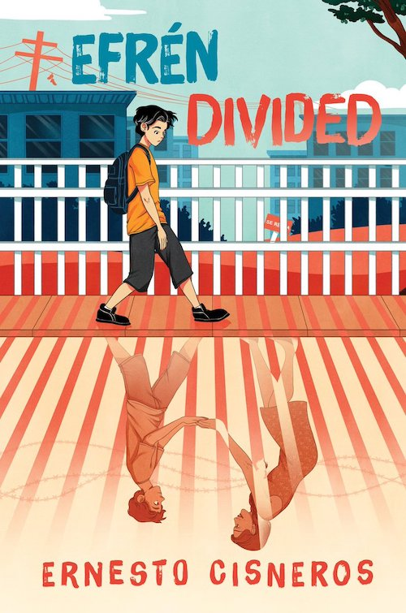
Teaching Efrén Divided:
A Re-Imagining Migration Educator’s Guide from Abeer Shinnawi and Adam Strom

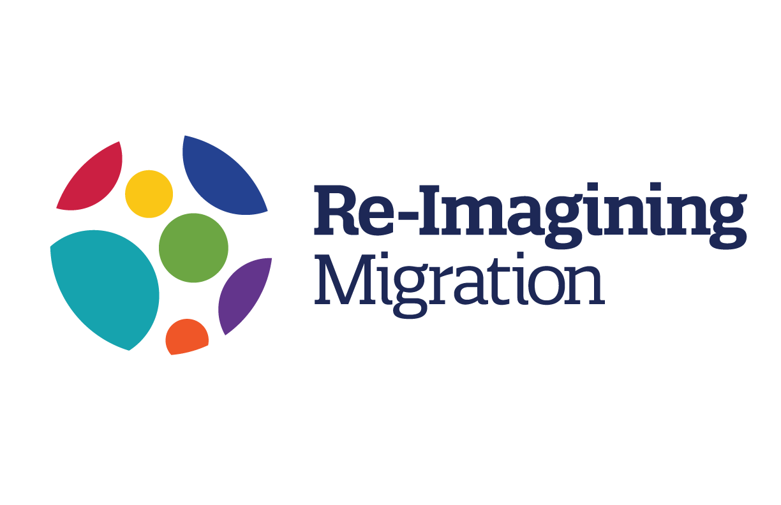

Table of Contents

Acknowledgments: 2
Before Teaching Efrén Divided 2
Introduction 2
Guiding Questions: 4
Book Summary 4
Author Biography 5
Author’s Note by Ernesto Cisneros 5
What should educators know before teaching Efrén Divided? 6
Reading Efrén Divided 8
Part 1: Windows and Mirrors 8
Part 2: Life without Amá 10
Part 3: Taking Action 12
After the Book: Reflections After Reading 15
Reflections 15
Extension Ideas: 16

Acknowledgments:
Re-Imagining Migration would like to thank Ernesto Cisneros for his kind attention, his wonderful book, and his contributions to this guide. We would also like to thank Emily Francis for introducing us to Efrén Divided. In addition, we would like to thank our co-founder Carola Suárez-Orozco for her groundbreaking research which serves as a quiet background to all of this work. Veronica Boix-Mansilla also deserves credit for her leadership for developing our framework and learning arc.

Before Teaching Efrén Divided

Introduction

Efrén Divided is the story of a tightly-knit immigrant family living in California sometime after 2016. When the book takes place, about one in seven people living in the U.S. were immigrants. 25% of those immigrants were from Mexico, like Efrén's family. While Efrén and his two siblings are U.S. Citizens, his parents are not. They fled violence in Mexico for safety in the United States and were living authorized, or undocumented, immigrants. The novel follows the challenges Efrén's family faces after his mother is picked up by immigration agents and deported to Mexico.

Think about that for a second. How would your life be different if one of the people you rely on the most to get you through your day was no longer there? Now imagine that you were 12, with one parent working long hours to make money for food and rent and two younger siblings who were now your responsibility. Being 12 can feel hard enough, balancing school, friendships, and family responsibilities. At the same time, we see that Efrén is resilient, with a network of friends and adults that help him adjust and become active at school and in the community.
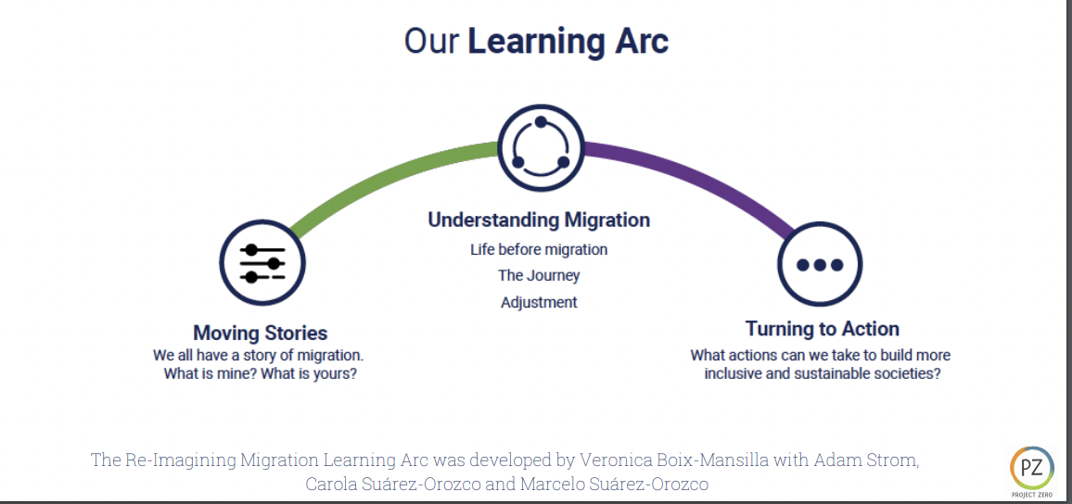
The narrative arc of Efrén Divided resembles the Re-Imagining Migration learning arc. Like our learning arc, the book begins by looking at the stories of an immigrant family within the context of their community. We call these Moving Stories, and the learning guide's questions in this section speak to themes we explore when we introduce Moving Stories: identity, community, and family stories. The second section of the learning arc is called Understanding Migration. In Efrén Divided, the book focuses on one aspect of the migration experience, the impact of borders. In the last third of the book, we follow Efrén and his friends as civic agents working for change in the school and society. In our learning arc, we call this turning to action. The driving question of this section of the learning arc is, "How can we take action toward more inclusive and sustainable societies?" We believe that learning about stories of people working to make a difference provides both a model for us to learn from and an invitation for us to get involved. For a full copy of the learning arc, follow this link.

As we think about both the books we read and the way we teach them, we often find ourselves reflecting on a fundamental observation articulated by Dr. Rudine Sims Bishop. Dr. Sims Bishop explained that "Books are sometimes windows, offering views of worlds that may be real or imagined, familiar or strange. These windows are also sliding glass doors and readers have only to walk through in imagination to become part of whatever world has been created or recreated by the author. When lighting conditions are just right, however, a window can also be a mirror. Literature transforms human experience and reflects it to us, and in that reflection, we can see our own lives and experiences as part of a larger human experience. Reading, then, becomes a means of self-affirmation, and readers often seek their mirrors in books."

With her words in mind, we should recognize that Efrén Divided will impact different readers differently. For some, the book will introduce them to a world that may be unfamiliar or they only know through media, myth, or stereotype. For others, the book might serve as a mirror in the way that House on Mango Street does for Efrén and Jennifer in the text. Our challenge as educators is to provide opportunities to recognize the experiences that we bring to the Efrén Divided and enhance them with a deep engagement with the story, and then reflect on them with our peers whose perspectives and personal experiences might be different than their own.

Finally, as teachers and readers, we need to remember that Efrén's story is one story of migration. There are others, and it would be a mistake to let a single story represent all migration experiences. Indeed, migration has been an integral part of our experience since humans first walked the earth; while it has ebbed and flowed over time, it is ubiquitous. Across history, skepticism, fear, and intolerance associated with differences have developed into deeply ingrained class and culture hierarchies leading to conflict, intolerance, and violence. In a world with more and more people on the move, educating young people to learn to live with, work with, and respect our differences is essential for the survival of democracy. This is not an option—it is imperative.

Guiding Questions:

- What can we learn from the many visible and invisible stories of migration around us?
- How do the visible and invisible borders that people encounter shape their lives?
- How might we use our voice and spheres of influence to create and sustain inclusive and welcoming communities?

Book Summary

An OwnVoices debut middle-grade novel about family, friendship, and tearing down the walls being built between all of us.
Efrén Nava’s Amá is his Superwoman—or Soperwoman, named after the delicious Mexican sopes his mother often prepares. Both Amá and Apá work hard all day to provide for the family, making sure Efrén and his younger siblings Max and Mía feel safe and loved.
But Efrén worries about his parents; although he’s American-born, his parents are undocumented. His worst nightmare comes true one day when Amá doesn’t return from work and is deported across the border to Tijuana, México.
Now more than ever, Efrén must channel his inner Soperboy to help take care of and try to reunite his family.

Author Biography
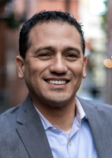

Author’s Note by Ernesto Cisneros

In recent years, hatred towards immigrants has been given a national platform. Many hurtful things continue to be said about the Latinx community, amongst others. The distortions were belittling and hurtful—they also appeared to be fueled by ignorance—and I do not want children internalizing the things they hear in the media.

I began writing Efrén Divided back in 2016, during the Presidential Election. I was outraged and wanted to take back control over the narrative; so that I could remind my students, as well as my own children at home, that our heritage is truly beautiful and not deserving of such animosity.

Part of the inspiration for the book were my students. I had three students who felt comfortable enough to confide in me the nightmares they were experiencing. With their trust, came a sense to do something to help. Giving a voice to their struggles wasn’t something I could turn my back on. I wanted readers not familiar with struggles of immigrant families to become more aware and sympathetic.

In addition, I wanted children like Efrén (who have undocumented family members) to know that they are not alone during their time of struggle. They have allies in their community: Teachers, counselors, librarians, peers, and neighbors who wish to help. Finally, I wanted these children to know that there is hope for change and that they can be a part of it.

The accolades EFRÉN DIVIDED has received are humbling to say the least—a dream come true. I never thought the publishing industry would ever embrace the story of an immigrant family in this way. I never expected it to resonate with so many people in the way it has.
However, the part I cherish most is hearing from teachers across the country, thanking me for writing a story for the children in their classrooms—those like Efrén. That is truly, the biggest honor I could ever receive.

And while Efrén’s world will certainly not align with that of every American, I would like for every reader to focus on the similarities rather than the differences between us. I am sure there is a bit of Efrén in everyone—a part that loves their family and friends and would sacrifice all they have for them.

What should educators know before teaching Efrén Divided?

What should educators know before teaching Efrén Divided and how should that knowledge shape their approach to teaching the novel? A Conversation with Re-Imagining Migration Executive Director Adam Strom and Carola Suárez-Orozco about immigrant-origin youth, mixed immigration status families, family separation and trauma.

https://youtu.be/9BAX5sGMMf4

Carola Suárez-Orozco is the Chair of Re-imagining Migration’s Board of Directors. She is also a Distinguished Professor of Education and Human Development at the University of Massachusetts, Boston and is the co-founder of Re-imagining Migration. Her books include: Children of Immigration (Harvard University Press), Learning a New Land (Harvard University Press), as well as the Transitions: The Development of the Children of Immigrants (NYU Press). She has been awarded an American Psychological Association (APA) Presidential Citation for her contributions to the understanding of cultural psychology of immigration, has served as Chair of the APA Presidential Task Force on Immigration, and is a member of the National Academy of Education. Her latest book is Immigrant-Origin Students in Community College: Navigating Risk and Reward in Higher Education.

Pre-Reading Activities:

Identities in Context:

All of us develop our identities within a social and cultural context. To a certain extent, that context influences the opportunities we have in life and our ability to express ourselves as we wish. Psychologist Uri Bronfenbrenner tried to capture the influence of the environment on people’s identities in what he called the Ecological Theory of Identity. In it, he tried to identify the various forces that shape the way we develop our sense of self.

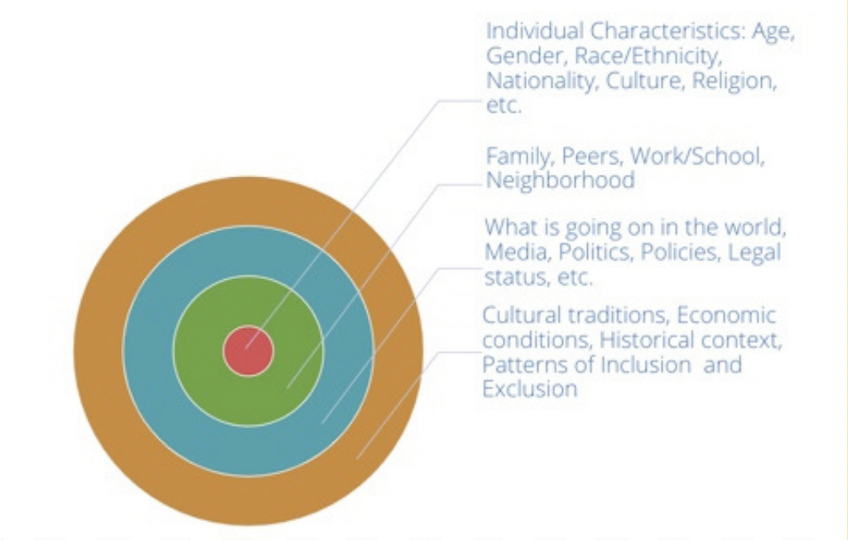
Identifying the way each layer of the ecological model relates to our identity is particularly helpful for exploring the ways that newcomers develop their identities in a new land because they, or their family members, have recently transitioned from one social and cultural context to another. Therefore, the relationship between their identities and their environment has changed. Helping to isolate those changes can help to clarify the way people navigate their lives in a new land.

Before beginning discussion of the book, create an ecological identity map for yourself. Throughout the guide, we encourage students to create a similar map for the characters they encounter in the book.

Moving Stories:

All of us have migration stories, whether in this generation or in the past, across internal borders of within, by choice, by force, or something in between. Before turning to the novel, you might encourage students to share their own moving stories using ideas from our learning guide. The core of the activity is having students interview each other, with proper contracting and guidance, using a set of questions that were developed by a group of learning scholars including educators, sociologists, and psychologists. Follow this link to the learning guide for ideas on how to structure the activity.

Reading Efrén Divided

Part 1: Windows and Mirrors

In the first few chapters of the book, we are introduced to Efrén's family. This provides an opportunity to focus on perspective-taking as we consider how our own lives are similar and different to Efrén's.

Guiding Questions:
We all have a story of migration - what is my story? What is yours?
● In what ways do stories of migration help us understand who we are?
● What can we learn from the many visible and invisible stories of migration around us?
● How can we approach the sharing of stories of migration with understanding and
compassion?

Reflection Questions:

- The first chapter introduces readers to Efrén’s family. What words would you use to describe the feelings at Efrén’s home? What words do you think Efrén would use? Identify words and phrases from the text that support your answer.

- What words or phrases might you use to describe life in your house? Compare the word lists drawn from your house and Efrén's. How are they similar? How are they different? How would you explain the similarities and differences?

- There are Spanish phrases mixed into the text. How do they impact your responses as a reader? If you don’t speak Spanish, did you look up the meaning of the words or did you read on? What is added by including Spanish in the text? Did you use the glossary at the end of the book? If so, why? If not, why not?

- Recognizing that our identities and opportunities are shaped by the way we see ourselves, as well as the way we are seen by others, and the environment in which we live, create an identity map for Amá and begin one for Efrén’s as well. You will want to add to both of these as you learn new information. For example, the early chapters include a lot of detail about the community and Efrén’s life at school.

- How would you describe Efrén’s relationship with his siblings? Note words or interactions that you think capture the spirit of their relationship.

- What role does school, and specific teachers, play in the lives of Efrén’s siblings? Choose a scene or a line from the text that you think best illustrates that relationship.

- What words would you use to describe David? How are Efrén and David similar? How are they different? How do you describe their relationship in this part of the book?

- How did their relationship evolve throughout the story?

- In chapter two, we are introduced to Jennifer. What are your first impressions of her? Consider referring to the ecological identity map to help describe her.

- Efrén’s favorite place at school is the library, it makes him feel free. Why did he feel that way about the library? What’s your favorite place? Why is your favorite place? How does it make you feel?

- In some ways, we all speak multiple languages, the language we speak formally, the language we speak with friends, and the language we speak at home. Sometimes people call that code-switching. Why do you think people code-switch? What would it be like if we always spoke the same way around different groups of people? What are the advantages of being able to code-switch and/or speak multiple languages?

- Jennifer’s favorite book is House on Mango Street. She explains that the girl in the book sounds a bit like her, and even uses Spanglish once in a while. Spanglish is an informal language that draws from Spanish and English, with sentences often including words in both languages. How does Spanglish connect her to that character who uses Spanglish. Do you speak multiple languages? If so, do you ever use them in the same sentence, or forget a word in one language and replace it with a word from another?

- Some people describe books as both windows into new worlds and mirrors in which we can see ourselves. What do you think Jennifer and Efrén are responding to when they read House on Mango Street? Is it a mirror, a window, or both? Explain. What about for you? If Efrén Divided a window into a different world? Is it a mirror of your own experience?

- Why do you think Jennifer wants to be class president? What about David? Why does he want to be president? How do David's feelings about running for class president evolve throughout the story?

- At the end of chapter two, we learn that Efrén's mother is being held in immigration detention by ICE. Based on what you have read so far, how do you think that this might impact him and his life?

Part 2: Life without Amá

Without Amá, life for Efrén and his family changes dramátically. Chapters 3-10 explore Efrén's family's resilience in the response to the changes and challenges they face as a mixed immigration status family in the U.S. Among the dispositions you might seek to emphasize during the discussion of the text are inquiry about migration stories with care and nuance, communicating across different perspectives and identities, and recognizing the inequities of treatment across identities and time.

Guiding Questions:

How do borders impact people’s lives?
● What is the purpose of borders?
● How do the visible and invisible borders that people encounter shape their lives?
●How can borders work in an ethical way?

How do individuals and societies navigate ambiguous immigration status?
● What are the rights of people with ambiguous immigration status (people who are not clearly recognized by the State)?
● How do individuals and societies manage ambiguous immigration status?
● What are our responsibilities toward people on the move with ambiguous immigration status?

Reflection Questions:

- How has Efrén's relationship with his siblings changed since Amá was taken away by ICE?

- What do you know about Efrén’s father? What responsibilities did he have before Amá was incarcerated? What additional responsibilities does he have now? How might these pressures impact his relationship with Efrén?

- Compare breakfast and the walk to school in chapter 1 with breakfast and the walk to school in chapters 4 and 5.

- What new pressure is Efrén facing? Does it impact his life? How does Efrén balance the new changes in his family routines? Where can he turn for help? You might revise the identity map you began for Efrén. What new words and ideas would you want to add? How might it be impacting the hopes and dreams he has for his future?

- Cisneros writes, “Four days without Amá and already Efrén’s world was starting to fall Apárt.” In what ways was that true? Where do you see it? Why might Efrén be reluctant to tell his friends and teachers what is going on? What might be the consequences if people found out? How might having to keep the challenges he is facing quiet impact his ability to manage the crisis he is facing?

- What do you think about the way Mr. Garrett responded to Efrén at the beginning and at the end of class? What clues does this have that Efrén might be having challenges at home? How might other teachers interpret those clues?

- Efrén tells Mr. Garrett that his mother has been deported. What do you think of his decision? How would Efrén know whether it was safe to trust Mr. Garrett? How does the conversation impact their relationship?

- At dinner, Efrén decides to tell the twins what happened to their mother as well. What do you notice about the way that the twins are responding to the situation?

- Efrén struggles to answer his siblings when they are sure Amá was a criminal. According to CNN, crossing the border without the approval of an immigration officer is a civil, but not a criminal offense. However, over 40% of undocumented immigrants crossed the border with authorization but “remained in the country without authorization after their visas had expired.” Attempting to answer his siblings’ question, Efrén compares the situation Amá is facing with Dr. Suess’s The Sneetches. Cisneros includes a short excerpt from The Sneetches in the epilogue to the book. What do you see as the connection between the quotation from The Sneetches and the challenges Amá, Efrén, and the rest of the family are facing?

- Efrén scans the internet reading about ICE activity in his community, following links to articles and blogs, most of them negative, about undocumented immigrants, and finally reads about the plan to build a giant wall across the U.S./Mexican border. Efrén ends up shutting his computer instead of doing his homework. How do you think the articles he read might influence the way he thinks about himself and his place in the country? How might those same articles influence others who did not have an undocumented parent, friend, or family member?

- How do the visible and invisible borders that Efrén and his family encounter shape their lives? What were the visible borders? What borders were invisible?

- Mr. Garrett explains that the class will visit the Museum of Tolerance in Los Angeles and teaches a lesson on the Holocaust using a quotation from Pastor Martin Neimoeller. Efrén wonders if Mr. Garrett might be teaching the lesson for him. What connection do you think Efrén is making between what is being taught and the situation he is facing? Use the Project Zero Same Different Gain to explore possible connections. What can be gained from this activity?

- David reveals that Efrén believes that the whole neighborhood “thinks I’m just a goofy gringo to laugh at.” If you were Efrén, how might you respond to your friend? What would you want to say? What advice might you have? What might you do?

- Towards the end of the chapter, we learn that one of the reasons that Efrén values his relationship with David is that Efrén never pities him. What does it mean to pity someone? How do you act towards someone you pity? What does it feel like to be pitied? Do you think there might have been a way for Efrén to ask for David’s support without jeopardizing their relationship?

- At the beginning of chapter 10 we learn that Jennifer’s mother was deported and Jennifer, who was born in the U.S. and therefore a U.S. citizen, had a terrible decision to make. If she stayed in the U.S. she would be taken to a social service agency or she could be deported along with her mother. Reflect on the passage where we learn about Jennifer’s dilemma. It is a very serious decision. Re-read the section and use the Project Zero See-Feel-Think-Wonder thinking routine to begin a discussion.

- What does it mean to be resilient? In what ways is Efrén’s family resilient? In what ways is Efrén resilient?

- Max receives a note from Jennifer who writes, “Eres una semilla” which means “you are a seed” in Spanish. What does she mean? What message is she sending Efrén? What does it have to do with resiliency?

- A lot is happening to Efrén that might feel troubling to readers at this point of the story. What does it feel like as a reader to take in all that is happening to Efrén and his family? If you were to choose one of the characters in the book to have a conversation with at this point of the story, which one would it be? What would you want to tell them? What would you want to know from them?

Part 3: Taking Action

In this final section of the book, we see Efrén begin to recognize his power and take on new responsibilities. While in earlier chapters, he focused on helping his family navigate the changes after his mother was deported, now he and his friends begin to take on new civic identities in school and in the community. These chapters are a good opportunity to continue to develop the disposition to recognize inequity as a way to deepen young people's empathy, ethical understanding, and sense of justice. It is also important to give students a chance to develop their civic imaginations through reflection on the choices made by Efrén, his friends, teachers, and members of the community.

Guiding Questions:

How can we take action toward more inclusive and sustainable societies?
- What issues related to migration do we care about and why?
- What can we learn from individuals and groups who have addressed migration in the past?
- How might we use our voice and spheres of influence to create and sustain inclusive and welcoming communities?

Reflection Questions

- Why do you think it was so important to David and Efrén to be president? If you were friends with both of them, what do you think you could do to help break the tension between them?
- In challenging times, support for others can make a big difference in helping someone be resilient. Where does Efrén get support?

- Reflect on Efrén’s interactions with Lalo. What does he add to the story? What is different about his perspective from others we have met through the text?

- Efrén volunteers to bring money to Amá because he thinks it is too risky for Apá to do it. Why would Efrén think the act would be too risky for Apá? Read the text closely. How do you think he felt before, during, and after giving his mother the money?

- If someone asked you why Apá fled to the US, how would you explain his decision? Many people leave their country out of fear of violence. To learn more, explore our civic challenge “The Rights of Refugees and Asylum Seekers” After researching asylum stories, consider, do you think Apá had a credible case for being granted asylum. Why or why not?

- As a reader, how did you feel when you learned that Amá had crossed the border? How did you feel when you learned she was being detained? How do you explain your responses? What shapes your perspective on the issue?

- What role do teachers play in the story? How did teachers in the book respond to the challenges that Jennifer and Efrén were having about their immigration status? For undocumented students, sharing information about their immigration status can be very dangerous. While some people might want to help, others might use that information in ways that could put their families in danger. How do you know who you can trust? What are the potential consequences when you trust the wrong person? How do you decide when to share a problem you are having with others? Consider how these connections to the book using the Project Zero Same-Different-Gain thinking routine:
- What is similar about that experience with the choices that Jennifer and Efrén faced?
- What is different?
- What might we learn by comparing the situations?

- What do you think are the qualities of a good teacher? What kind of impact can a good teacher have on the life of a student? What qualities do Mr. Garnett and Ms. Solomon display?

- Sanda Cisneros’ novel The House on Mango Street becomes important to Efrén, just like it was for Jennifer. In the final chapter, a few lines from the book grab him: "Like it or not you are Mango Street, and one day you'll come back too." Why do you think that line meant so much to Efrén at this point of the story?

- Efrén discovers that his campaign posters have been defaced with racist language calling for her deportation. How might Efrén feel? Have you ever been the target of prejudice? What does it feel like? Have you ever witnessed an act of prejudice and not stepped in to help?

- One of the most common forms of racial bullying and harassment in schools is calling someone illegal or telling people, even people who were born in the U.S., to go back to their own country. The office of the United Nations High Commissioner for Refugees explains, "Calling immigrants illegal' denies their innate dignity and human rights. Characterizing migrants' existence as illegitimate ignores their experiences as workers, women, men, children, families, and the elderly. When dehumanizing terms are accepted as the norm, people are turned into targets of contempt, and even their right to life may come under threat." Using your own words, what does the office of the United Nations High Commissioner for Refugees think is at stake when people are called illegal?

- David explains that despite the conflict, he had to take action against the racist attacks targeting Efrén. He explains, "When I moved here, you never treated me differently, even if I was the only white kid on the block." Have you ever witnessed an act of prejudice and stood up? Think about the situation. Why do you think you didn't stand up in one instance but did stand up in the other?

- Both David and Efrén, at different times, took action to make their school and neighborhood more inclusive and welcoming. And, at the very end of the book Efrén, Jennifer, David, and Han all team up to help educate parents about their rights. What can you do to help make your school and neighborhood more welcoming? What can you learn from the way Efrén treated David when he first arrived?

- How would you describe the end of the book? What surprised you? What interested you? Is there anything that is still troubling about the end?

After the Book: Reflections After Reading

Reflections

Ask students to consider the 4 'C's:

- Connections: What connections do you draw between the text and your own life or your other learning?
- Challenge: What ideas, positions, or assumptions do you want to challenge or argue with in the text?
- Concepts: What key concepts or ideas do you think are important and worth holding on to from the text?
- Changes: What changes in attitudes, thinking, or action are suggested by the text, either for you or others?

Consider the significance of the book following Project Zero’s Three Why’s Thinking Routine:
- Why does this novel matter to me?
- Why does it matter to my community?
- Why does it matter to the world?

The U.S. Department of Health and Human Services writes, “Encouraging young people to be active in their community is important for promoting life-long civic participation. One study found that high school students involved in community service are more likely to vote and volunteer in adulthood.” After reading the book, ask students to consider what they can do to help create welcoming and inclusive communities for people like Efrén and other newcomers. If they need some structure to help brainstorm ideas, follow this link to a series of thinking routines we have curated to help young people exercise their civic imaginations. One great example is the seesaws that have been built along the border wall so that kids on both sides of the border can play together. What this short CNN video to see the project in action

Extension Ideas:

Efrén Divided is a powerful launch for students’ further inquiries about the history of ambiguous
status and immigration policies. The topics listed below are ones that students could use for their own research topics on Government policies, immigration trends and personal accounts.
Educators could work with students to determine the best way to share their knowledge.

Migration Policy Institute: Have students use the search tab to find statistics, articles, and policy briefs around migration.

Immigration History: What are historic landmarks in the history of immigration to the U.S. and what is their significance? In particular, the history of the U.S. Mexican border has roots in the Treaty of Guadalupe Hidalgo that was signed after the Mexican-American war.
.
Family Separation: Student’s might begin their research with learning from people who have experienced Family Separation, including actress Diana Gurerro and scholars who have studied the impact of family separation on children.

