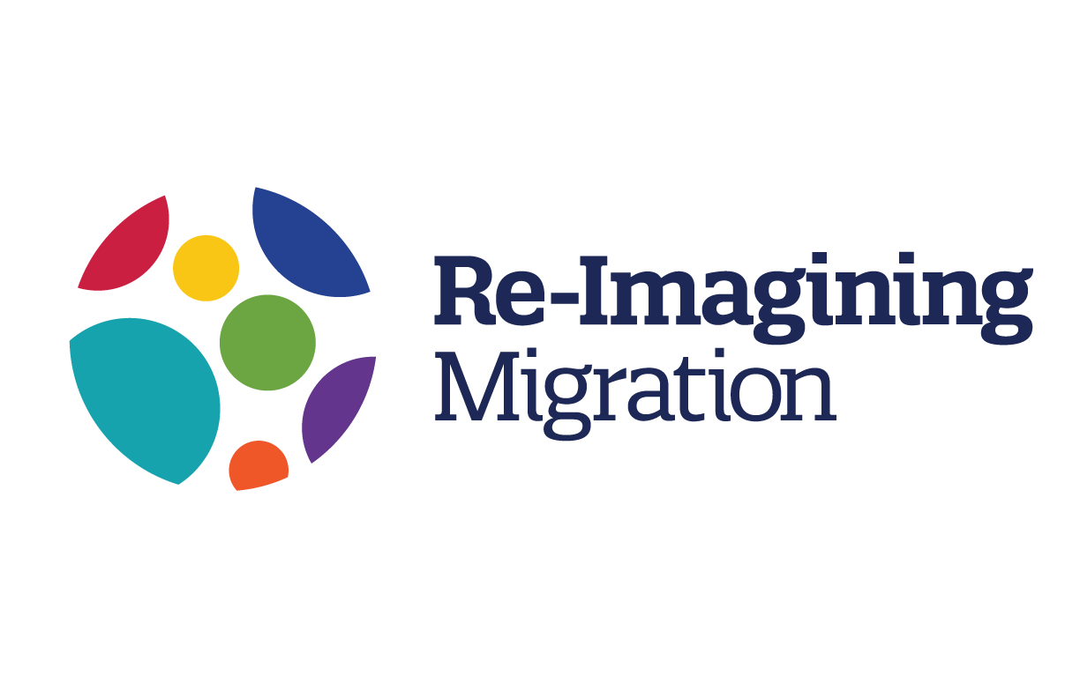

A PRACTICAL TOOL TO INSPIRE AND SUPPORT QUALITY TEACHING FOR A WORLD ON THE MOVE

By Veronica Boix-Mansilla and Adam Strom

Re-imagining Migration’s approach to teaching is grounded in our framework and begins with the recognition that good teaching is always developed in relationship to the students that we teach, the community that in which we teach, the culture of our schools and classrooms, as well as the academic disciplines and courses in which lessons are delivered and designed.
Our approach builds on a belief that good teaching, and good curriculum, is always in dialogue with the students in our care, our learning goals, and the dispositions we seek to nurture, the content we are teaching, and the kinds of classroom practices that promote student engagement, understanding, and action.
We invite you to explore the teaching designs reflection tools below as you consider what to teach, why and how. The tool provides a series of questions that may support your design choices. Teaching as we view it is not merely a matter of sharing information- rather, it is one of nurturing holistic, relevant, deep, and lasting understandings that transform students, nurturing their full potential, empowering them to live fulfilling lives and to participate actively in the construction of more inclusive, equitable and sustainable societies.
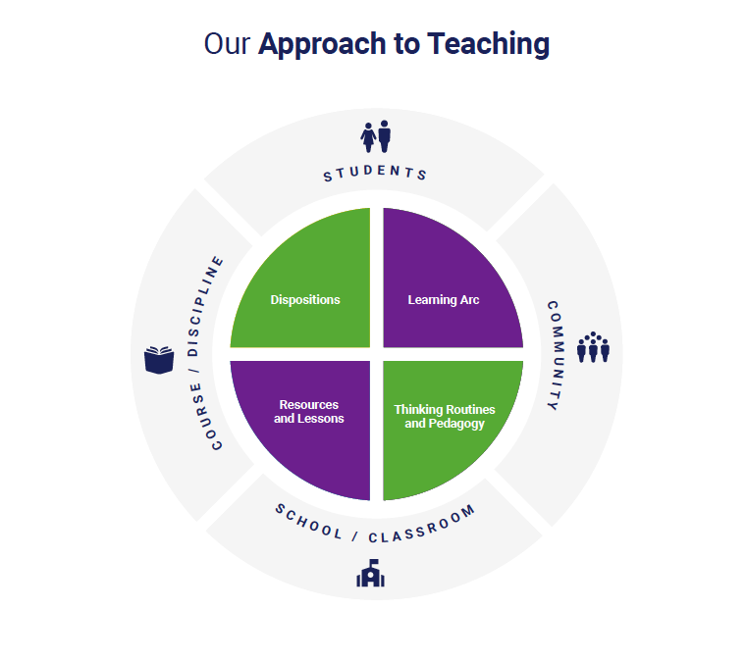”Re-Imagining Migration’s approach builds on a belief that good teaching, and good curriculum, is always in a dialogue between the students in our care, our learning goals, and the dispositions we seek to nurture, the content we are teaching, and the kinds of classroom practices that promote student engagement, understanding, & action.”

What matters most for my students to learn and why

in a world on the move?

EXPLORING THE LEARNING ARC and DISPOSITIONS MAP

Focus | Design |  | Reflect
Topic  What is the essential topic or big question about migration that my learners will explore?  Why does it matter to my students, to society, to the discipline(s) I teach?  Why does teaching this topic matter to me? | Topic:  Why does it matter? |  | My topic or guiding question:  - How is it relevant and responsive to my students’ lives, contexts, cultures?  - How does it address essential aspects of the human migration experience [see learning arc]?  - Does it invite my students to learn important ideas and modes of thinking from the discipline(s) I teach?  - How does the topic contribute to decrease bias and hatred against young people of diverse origins?  - How can I frame it for students so that they will engage cognitively, socially, emotionally?
Learning  Goals  What specific understandings about the topic and dispositions will my students develop?  What opportunities might emerge along the way? | Students will come to appreciate and/or understand… |  | Understandings and Dispositions  - Do they capture the most relevant aspects of the topic above [e.g., big ideas, powerful re-framings, habits of mind]?  - Do they respond to diverse students’ backgrounds, elevating cultural assets, and attending to needs?  - How can I develop and share learning expectations with students so that they “own” their project meaningfully?
 | - Leave open for emerging goals
 | They will develop the disposition to…

What will my students do to learn and how will they make their learning visible?

EXPLORING RESOURCES AND THINKING ROUTINES

Focus | Design |  |  | Reflect
Key Learning Experiences  What will my students experience, do, or think to build core understandings and solidify/ synthesize/ reflect about their learning?  What kinds of materials, provocations, and / or thinking routines will engage students in meaningful learning?  How will I make my students’ learning visible to support them further? | experiences + resources + thinking routines + visibility |  |  | Designing Learning Experiences  What kinds of personally meaningful experiences might engage the whole student in the topic meaningfully, as we begin this exploration?  What culturally relevant resources or provocations might empower my students to build deep and relevant understanding (e.g. stories, community assets, family member, works of art, primary sources, news)?  What might be challenging for my students in this unit or project (academically, emotionally, personally) and how will I support them?  What opportunities will students have to grapple with information in novel ways (e.g. interpret, explain, empathize) to build understanding?  What opportunities will they have to practice and develop dispositions for a world on the move? (e.g. taking perspective with empathy, recognizing inequities, taking action)  What opportunities will we find for students to shape their own learning and the transformations necessary to live in a world on the move?
 | Introductory experience:
 | Experience to dig deeper:
 | Experience to dig deeper:
 | Culminating Experience:

Reflecting on my students’ and my own learning

Assessing and reflecting  What do I value about my student and my own learning in this unit?  What surprised me?  What might they or I do next to continue to foster learning and transformation? | About my student(s)’ learning
 | What I Value | What surprised me | What they might do next
 | About my teaching
 | What I Value | What surprised me | What they might do next

